|  |  |  |  |
| --- | --- | --- | --- |
| Year 12 Worksheet 3 – Formative Assessment 1  **Waves** | | | |
|  | | | |
| **Name:** | **Teacher:** | **Score /15** | |
| **Comment:** | | | **Time allowed:**  **15 minutes** |

1. Waves can be classified either as how they move, or whether they require matter to transfer energy. Read the descriptions below, and then write the classification term that best matches the description.

|  |  |
| --- | --- |
| Waves that require matter as a medium to propagate. | **Mechanical ( ½ Mark )** |
| Waves that do not require as a medium to propagate. | **Electromagnetic ( ½ Mark )** |
| Waves in which the oscillation is parallel to the direction of energy transfer. | **Longitudinal ( ½ Mark )** |
| Waves in which the oscillation is perpendicular to the direction of energy transfer | **Transverse ( ½ Mark )** |

1. Label the two parts of the wave shown with arrows below, using the correct term::

0

*t*

*t*

0

displacement

2

1

time

**Period**

**Amplitude**

1. What is the period of a wave that has a frequency of 60.Hz?
2. 2.0 x 104s
3. 3.0 x 10-3s
4. 1.7 x 10-2s
5. 3.3 x 102s
6. What is the wavelength of a 30 Hz periodic wave moving at 60 ms-1?
7. 20.m
8. 1800 m
9. 50 m
10. 2.0 m
11. Two waves have the same frequency. Which wave characteristic must also be identical for both waves?
12. amplitude
13. period
14. phase
15. intensity
16. The number of water waves passing a given point each second is the waves
17. Amplitude
18. wavelength
19. Velocity
20. Frequency
21. As the frequency of a wave increases, the period of that wave
22. decreases
23. remains the same
24. increases
25. Wave motion in a medium transfers
26. both mass and energy
27. neither mass nor energy
28. energy, only
29. mass, only
30. Which of the following is an example of a longitudinal wave?
31. An x-ray
32. A mexican wave
33. A water wave
34. A sound wave
35. A wave traveling at 5.0 x 104 meters per second has wavelength of 2.5 x 101 metres. What is the frequency of the wave?
36. 5.0 x 10-4 Hz
37. 2.0 x 103 Hz
38. 1.25 x 106 Hz
39. 5.0 x 103 Hz
40. A sound wave has a period of 0.005 s and a velocity of 346 ms-1. What is its wavelength?
41. 6.92 x 103 m
42. 1.73 m
43. 5.78 x 10-1 m
44. There is not enough information to calculate wavelength.
45. 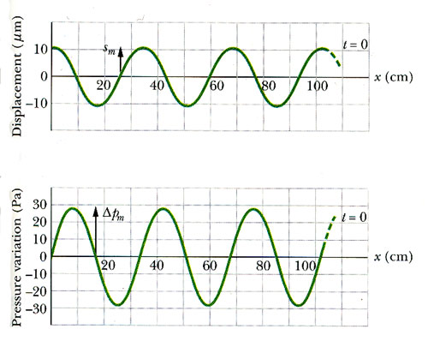The wave in the diagram has a frequency to 250Hz. Its velocity is closest to which of the following?
46. 85 ms-1
47. 2500 ms-1
48. 7.35 ms-1
49. 8500 ms-1
50. The frequency of a tuning fork that vibrates 6000 times in 5 s is _______.
51. 6000 Hz
52. 1200 Hz
53. 30000 Hz
54. 8.33 x 10-4 Hz